- Install nginx and run nginx on port number 81.
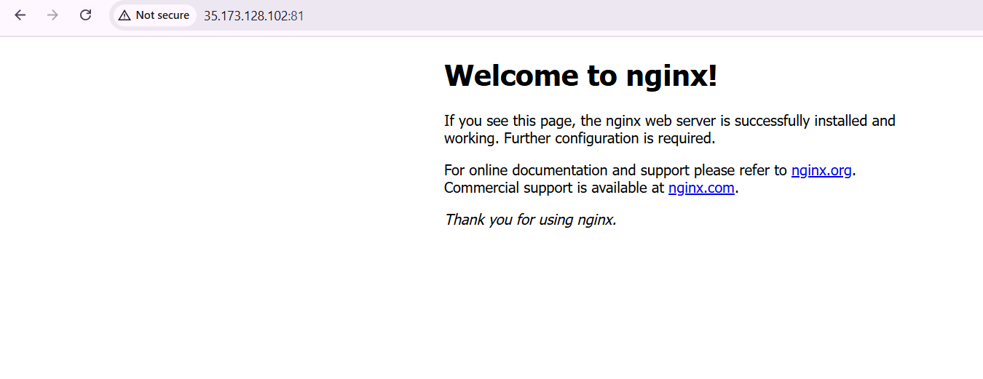
- Deploy a sample index.html file on nginx.

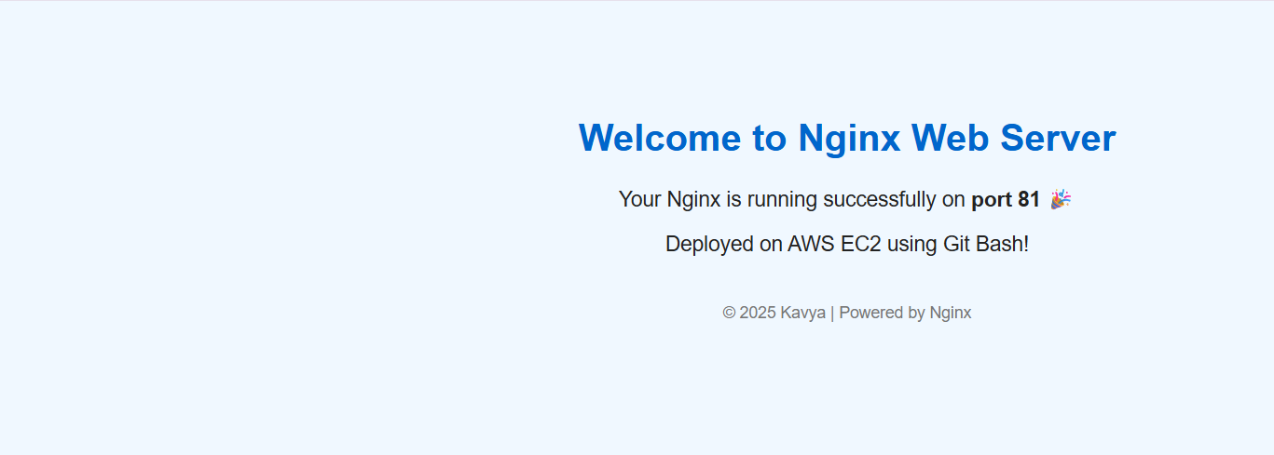

- Install Apache and run Apache on port number 82
- Deploy a sample index.html file on Apache.
- Install Apache tomcat on port number 8082
- Deploy a sample app on webapps
- Create a tomcat.service file for tomcat.
- Configure HA Proxy server

